

January 10, 2019

General Description

Description of the bandwidth change process in Odoo.

Odoo - Bandwidth Change

Odoo - Bandwidth Change

Table of Contents

Overview 2

Accessing Bandwidth Changes 2

Creating a New Bandwidth Change 3

Initiation 3

NOC Analysis 5

Wait for Land 6

Out for Signatures 6

NOC Implementing 7

Complete 7

Issue Handling 8

# Overview

The bandwidth (BW) change process within Odoo allows the user to track the progress of the change request as it progresses through the stages. Odoo also provides a place to store the documentation, acting as a historic repository of BW changes for the various sites.

# Accessing Bandwidth Changes

Bandwidth Changes are accessible on the main Odoo menu and clicking the BW Changes App. BW Changes do have permissions so if they don’t show then see your manager to have access granted.

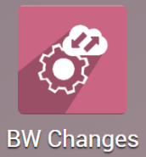

Once in the app, you will see the Kanban view showing the BW Changes and their stages. You can switch to the list view by using the icons in the top right of the screen. Click any of the cards to open the BW Change form.

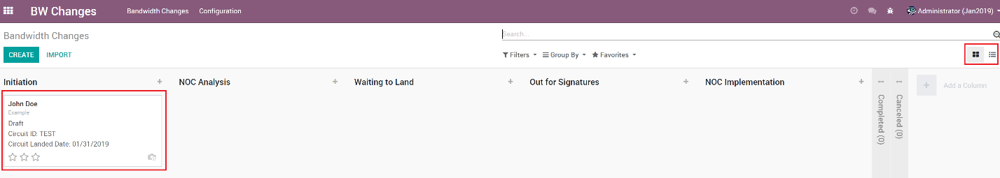

# Creating a New Bandwidth Change

Creating a new Bandwidth Change is done from the main view of the app.

1. Open the BW Changes App.
2. Click the ‘**Create’** button.

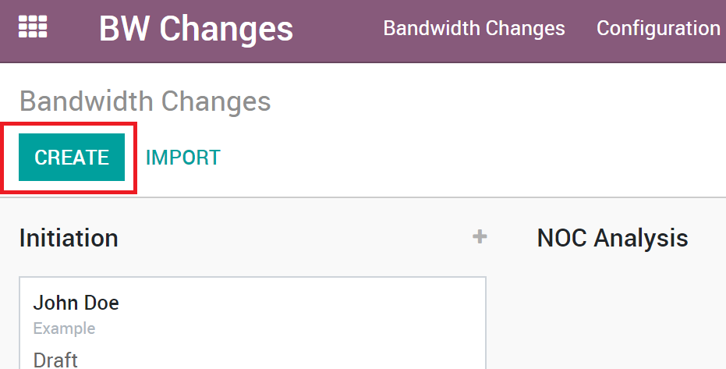

The BW Change form view will be opened.

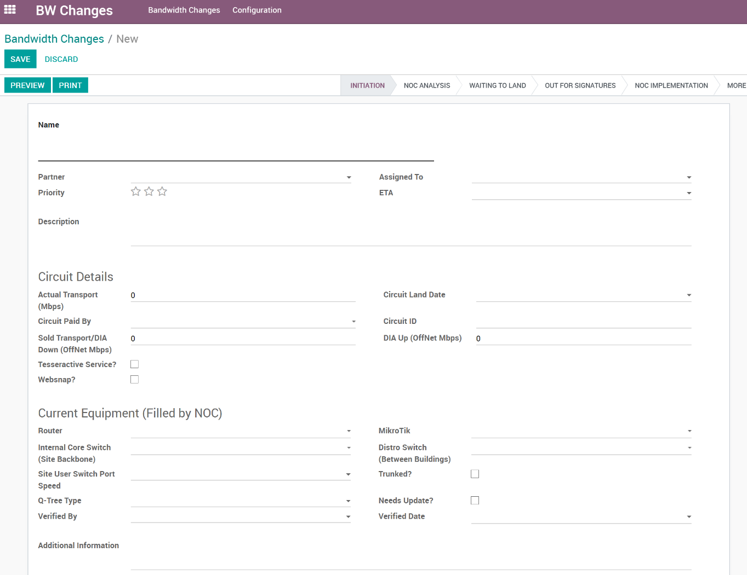

The stages of the Business Process Flow are **Initiation**, **NOC Analysis**, **Waiting to Land**, **Out for Signatures**, **NOC Implemention**, **Completed**.

## Initiation

The initiation stage is where most of the information regarding the account and BW changes resides.

**Name:** Can be the name of the account or can be a project name if the change is for an internal project for example,1G Initiative.

**Partner:** Is the name of the account/parnter associated with the BW Change.

**Assigned To:** The person responsible for filling out the information and seeing that the BW Change moves through the process.

**Priority**: You can set the priority to track higher priority items that need more attention.

**Description:** Description is an expanded explanation of why the BW change is taking place

**Actual Transport**: Is the speed in megabits per second. This information is available from the BW purchase order (PO) form in the speed column.

**Circuit Paid By**: This is a dropdown to choose if Pavlov Media (aka Company) is paying the cost for the circuit or if the Customer is paying the costs. This information would be contained in the Service Order (SO) for changes coming from the Sales Team.

**Sold Transport:** The transport speed sold to the property, this may be less than the actual transport to allow for upgrades in the future. Sold transport information will be available in the contract.

**DIA Upload:** Direct Internet Access upload speed for Offnet, this information is provided from the contract.

**Tesseractiv Service:** Is Pavlov Media providing Tesseractiv Service to the property? Choose from the dropdown choices of No, Complimentary, Sold or N/A. This is per the contract and in most cases complimentary to the property.

**Tesseractiv Speed:** Tesseractiv Speed OnNet information is per the contractual circuit information.

**Websnap:** Websnap is burst to the circuit download speed subject a maximum equal to the LAN circuit speed)

**Websnap Download Speed:** Websnap download speed if applicable will be found as part of the contractual circuit information.

**User/Unit Package Download:** Download speeds will be provided as part of the contractual circuit information.

**User/Unit Package Upload:** Upload speeds will be provided as part of the contractual circuit information.

**Unregistered Down (Mbps):** Unregistered download speeds will be provided as part of the contractual circuit information.

**Unregistered Up (Mbps):** Unregistered upload speeds will be provided as part of the contractual circuit information.

**Unregistered Tesseractiv (Mbps):** Unregistered Tesseractiv speeds will be provided as part of the contractual circuit information.

**Reason for Change:** Provide brief explanation of why the change is taking place. For example; If there is a new contract, amended contract and so on.

**Contract Executed Date:** Provided by either the Service Order (SO) or the contract.

When all the information has been completed for the initiation stage save the information and move to the NOC Analysis stage.

## NOC Analysis

This stage will mean that NOC needs to perform the verification. When moved to this stage, an email will be automatically sent so that it can be assigned to individual in NOC to perform the verification and fill in the following information.

**Router:** From the drop-down menu the user can choose 10/100, 10/100/1000, 10/100/1000/10000 or N/A to reflect what the property has on site.

**MikroTik:** From the drop-down menu the user can choose 10/100, 10/100/1000, 10/100/1000/10000 or N/A to reflect what the property has on site.

**Internal Core Switch (Site Backbone):** From the drop-down menu the user can choose 10/100, 10/100/1000, 10/100/1000/10000 or N/A to reflect what the property has on site.

**Distribution Switch (Building):** From the drop-down menu the user can choose 10/100, 10/100/1000, 10/100/1000/10000 or N/A to reflect what the property has on site.

**Trunked?:** Choose yes or no an whether the site is trunked or not.

**Needs update?** Choose yes if the equipment onsite needs to be updated in order to handle the BW that will be implemented or no if the equipment is ok for the BW. If there is additional equipment needed note this in the Additional Notes of this workflow.

**Q-Tree Type:** Designate if this is a standard update, if the BW change is less than 1 Gig, by choosing queue tree standard. If the BW update is over 1 Gig choose Queue Tree Light. This information will be provided to the NOC Level 3 for when the queue trees are updated.

**Site User Switch Port Speed:** From the drop-down menu the user can choose 10/100, 10/100/1000, 10/100/1000/10000 or N/A to reflect what the property has on site.

**Verified By:** The NOC analyst who verified the equipment.

**Verified Date:** The date the equipment verification was completed.

**Additional Notes:** Enter any further information that pertains the equipment verification performed for the site.

If it’s determine that equipment is needed, then start the process to get that equipment configured and sent to the site to be installed. Coordination with the Bandwidth Team will be needed during that process.

Click save at the top left of the screen and move to the ‘Waiting to Land’ stage.

## Waiting to Land

There is a period when a BW Change will be in a holding state waiting for the BW to land at the property. Once the BW lands an email is sent to the appropriate teams from the BW team. When the email is received the BW Change process can continue.

**ETA:** Is the estimated time that the BW is to arrive at the site; this date can be obtained from the PM’s and should not be any later than the live date for deployment. The ETA can be filled out before the email is received from the BW team.

**Circuit ID:** The circuit ID is provided from the BW email. The ID is combination of numbers and letters.

**Circuit Land Date:** The circuit land date reflects the date the circuit landed at the site.

## Out for Signatures

Before the BW Change can be sent to NOC to have the queue trees prepared, signatures from the Legal team and CEO must be obtained. The queue trees cannot be updated without the signatures being provided.

To print the form for the signatures, click on the ‘**Print**’ button. You can also preview by clicking the ‘**Preview**’ button. The preview also has a ‘**Print**’ button where it can be printed.

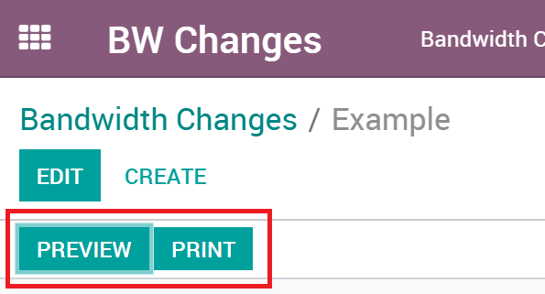

When the signatures have been collected the signed Word document will need to be uploaded the bottom of the BW Change form. Click the ‘**Upload your file**’ to upload the signed, finalized document.

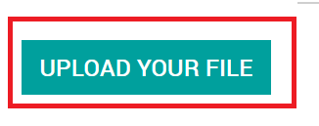

The BW change form is now ready to be submitted to NOC to have the queue trees updated. To send the information to NOC, just move it to the ‘**NOC Implementation**’ stage, which will send an email to aleart the NOC manager to assign this to be worked.

## NOC Implementation

This is when NOC implements the queue trees are are responsible for updating this portion of the workflow.

**NOC Implemented By:** Is the name of the person who updated the queue trees.

**NOC Implementation Notes:** Is an area that any additional information can be recorded.

**Queue Tree Type:** Set this field to queue tree standard if the change is less than 1G; set to queue tree light if the change is over 1G.

Save the information and the NOC person who implemented the changes should notify the person responsible for the BW Change to review it.

## Complete

To complete the BW Change process there are a few steps outside of Odoo that need to be completed. When each of those steps have been achieved then move the BW Change to the ‘**completed’** stage.

This will complete the BW Change process..

# Issue Handling

For issues that may arise submit a MIS ticket for the System Integration team to investigate the issue; below is the link to the ticketing system.

<https://cwise.shout.net/v4_6_release/services/system_io/customerportal/portal.html?company=sgt&locale=en#LoginPagePlace:LOGOUT>